Trent Giever

CS &141

Ch 6

4/21/2020

Problem # 8

Code:

///////////////////////////////////////////////////////////////////

/\*

Programmer: Trent Giever

Assignment Chapter: 6

Purpose: CahRegister class and file

Date modified: 4/21/2020

IDE/Tool used: NetBeans 8.2

\*/

package ch.pkg6.pkg1;

import static java.lang.System.out;

import java.util.Scanner;

public class Ch61

{

public static void main(String[] args)

{

//variables to hold the data before being passed to the class objects

String desc ="";

int itemNum =0, quantity =0;

double wholesale=0, retail=0;

//getting in the values to pass to the classes

Scanner in = new Scanner(System.in);

out.print("Please enter the item number: ");

itemNum = in.nextInt();

in.nextLine();

out.print("Enter the items description: ");

desc = in.nextLine();

out.print("Enter the retail cost: $");

retail = in.nextDouble();

out.print("Enter the wholesale cost: $");

wholesale = in.nextDouble();

//create the RetailItem object

RetailItem item = new RetailItem(desc, itemNum, wholesale, retail);

//create the CashRegister object

out.print("How many of the item do you want to buy: ");

quantity = in.nextInt();

CashRegister sale = new CashRegister(item, quantity);

//print the results to the screen

out.println(item);

out.println("The subtotal is: $" + sale.getSubtotal());

out.println("The tax is: $" + sale.getTax());

out.println("The total is: $" + sale.getTotal());

}

}

////////////////////////////////////////////////////////////////////////////////

package ch.pkg6.pkg1;

import java.text.DecimalFormat;

/\*\*

\* This class uses an inner class.

\*/

public class RetailItem

{

private String description; // Item description

private int itemNumber; // Item number

private CostData cost; // Cost data

/\*\*

\* RetailItem class constructor

\*/

public RetailItem(String desc, int itemNum,

double wholesale, double retail)

{

description = desc;

itemNumber = itemNum;

cost = new CostData(wholesale, retail);

}

/\*\*

\* RetailItem class toString method

\*/

public double getWholesale() //returns wholesale

{

return cost.getwholesale();

}

public void setWholesale(double wholesale) //sets wholesale

{

cost.setwholesale(wholesale);

}

public double getRetail() //returns retail

{

return cost.getretail();

}

public void setRetail(double retail) //sets retail

{

cost.setretail(retail);

}

public String toString() // overrides toString method

{

String str; // To hold a descriptive string.

// Create a DecimalFormat object to format output.

DecimalFormat dollar = new DecimalFormat("#,##0.00");

// Create a string describing the item.

str = "Description: " + description

+ "\nItem Number: " + itemNumber

+ "\nWholesale Cost: $"

+ dollar.format(cost.wholesale)

+ "\nRetail Price: $"

+ dollar.format(cost.retail);

// Return the string.

return str;

}

/\*\*

\* CostData Inner Class

\*/

private class CostData

{

private double wholesale, // Wholesale cost

retail; // Retail price

/\*\*

\* CostData class constructor

\*/

public CostData(double w, double r)

{

wholesale = w;

retail = r;

}

public double getwholesale() //gets wholesale value

{

return wholesale;

}

public void setwholesale(double wholesale) //sets wholesale

{

this.wholesale = wholesale;

}

public double getretail() //get retail

{

return retail;

}

public void setretail(double retail) //set retail

{

this.retail = retail;

}

}

}

/////////////////////////////////////////////////////////////////////////////////////////////

/\*

\* To change this license header, choose License Headers in Project Properties.

\* To change this template file, choose Tools | Templates

\* and open the template in the editor.

\*/

package ch.pkg6.pkg1;

/\*\*

\*

\* @author trgie

\*/

public class CashRegister

{

private int quantity; //quantity buying

private RetailItem sale; //object of RetailItem

public CashRegister(RetailItem sale, int quantity) //constructor

{

this.sale = sale;

this.quantity = quantity;

}

public double getSubtotal() //returns the subtotal

{

return sale.getRetail() \* quantity;

}

public double getTax() //returns the amount of tax

{

return sale.getRetail() \* .06 \* quantity;

}

public double getTotal() //returns the grand total

{

return getSubtotal() + getTax();

}

}

Snip:

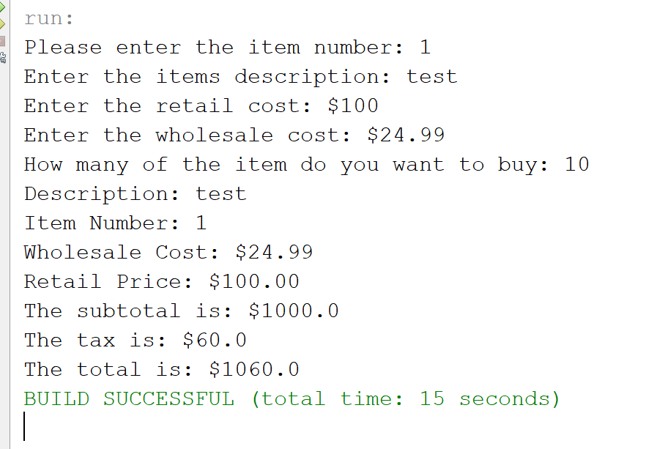

Program # 15

Code:

Changes Only

/\*

Programmer: Trent Giever

Assignment Chapter: 6

Purpose: CahRegister class and file

Date modified: 4/21/2020

IDE/Tool used: NetBeans 8.2

\*/

package ch.pkg6.pkg1;

import java.io.File;

import java.io.IOException;

import java.io.PrintWriter;

import static java.lang.System.out;

import java.util.Scanner;

public class Ch61

{

public static void main(String[] args) throws IOException

{

//variables to hold the data before being passed to the class objects

String desc ="";

int itemNum =0, quantity =0;

double wholesale=0, retail=0;

//getting in the values to pass to the classes

Scanner in = new Scanner(System.in);

out.print("Please enter the item number: ");

itemNum = in.nextInt();

in.nextLine();

out.print("Enter the items description: ");

desc = in.nextLine();

out.print("Enter the retail cost: $");

retail = in.nextDouble();

out.print("Enter the wholesale cost: $");

wholesale = in.nextDouble();

//create the RetailItem object

RetailItem item = new RetailItem(desc, itemNum, wholesale, retail);

//create the CashRegister object

out.print("How many of the item do you want to buy: ");

quantity = in.nextInt();

CashRegister sale = new CashRegister(item, quantity);

//print the results to the screen

out.println(item);

out.println("The subtotal is: $" + sale.getSubtotal());

out.println("The tax is: $" + sale.getTax());

out.println("The total is: $" + sale.getTotal());

File myFile = new File("Receipt.dat");

PrintWriter writetoFile = new PrintWriter(myFile);

writetoFile.println(item);

writetoFile.println("The subtotal is: $" + sale.getSubtotal());

writetoFile.println("The tax is: $" + sale.getTax());

writetoFile.println("The total is: $" + sale.getTotal());

writetoFile.close();

}

}

Snip:

